H.T No
Regulations:
A22

Sreenidhi Institute of Science and Technology
(An Autonomous Institution)
Code No: 9FC83 Date:30-January-2025 (AN)

B.Tech III-Year I- Semester External Examination, January-2025 (Regular)
DATA WAREHOUSING AND MINING (CS and DS)

Time: 3 Hours Max.Marks:60

Note: a) No additional answer sheets will be provided.
b) All sub-parts of a question must be answered at one place only, otherwise it will not be valued.
c) Missing data can be assumed suitably.
Bloom's Cognitive Levels of Learning (BCLL)

Remember | L1 | Apply | L3 | Evaluate | L5
Understand | L2 | Analyze | L4 | Create | L6

Part - A Max.Marks: 6x2=12

Answer all QUESTIONS, EACH QUESTION CARRIES 2 MARKS.

 |  | BCLL | CO(s) | Marks
1 | List two major issues in data mining. | L1 | CO1 | [2M]
2 | Define data reduction in data preprocessing. | L1 | CO2 | [2M]
3 | List Multi dimensional models. | L1 | CO3 | [2M]
4 | Define frequent patterns association rules in data mining. | L1 | CO4 | [2M]
5 | Define prediction and name two prediction techniques. | L2 | CO5 | [2M]
6 | Differentiate between Cluster and Classification | L2 | CO6 | [2M]

Part – B Max.Marks: 6x8=48
ANSWER ALL QUESTIONS. EACH QUESTION CARRIES 8 MARKS.

 |  | BCLL | CO(s) | Marks
7. | Explain data mining functionalities with examples. | L2 | CO1 | [8M]
 | OR
8 | Explain Data Mining Task Primitives with examples. | L1 | CO1 | [8M]
9. | Explain data cleaning and data integration in detail. | L4 | CO2 | [8M]
 | OR
10 | Describe concept hierarchy generation and summarize the need of data preprocessing. | L2 | CO2 | [8M]
11 | Discuss in detail Data Warehouse architecture with a neat diagram. | L2 | CO3 | [8M]
 | OR
12 | Discuss the importance of Data Warehousing in decision-making and explain the OLAP operations with examples. | L2 | CO3 | [8M]
13 | Find frequent item sets and strong association rules using Apriori algorithm with support count = 2 and confidence = 60%.  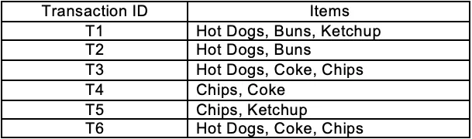 | L5 | CO4 | [8M]
 | OR
14 | Discuss multi level association rules from transaction databases. | L4 | CO4 | [8M]
15 | Explain support vector machine for both linear and non-linear data. | L4 | CO5 | [8M]
 | OR
16 | Describe the process of classification by Decision Tree Induction with an example. | L3 | CO5 | [8M]
17 | Discuss partitioning methods for clustering. | L2 | CO6 | [8M]
 | OR
18 | Explain density-based methods for clustering. | L3 | CO6 | [8M]

-- 00 -- 00 –

